Can you match the member of staff to their favourite childhood book on both pages?
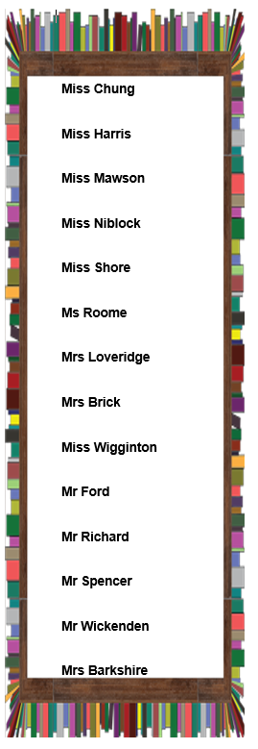
To make it easier I have put the book titles on the correct page – you just need to work out which member of staff it belongs to.

